CHAPTER 1 INTRODUCTION

Fire accidents pose serious threats to life and property, especially in domestic and industrial environments where quick response is essential. Traditional fire detection methods often rely on manual monitoring and human intervention, which can be slow, inefficient, and prone to error. These limitations highlight the need for an automated and reliable system capable of detecting and extinguishing fire at an early stage.
Agnirodhak: An Automated Fire detection and Extinguishing system is designed to provide an intelligent and self-operating fire response solution. The system uses an Infrared (IR) flame sensor to detect the presence of fire based on infrared radiation. When a flame is detected, the sensor sends a signal to a BD140 PNP transistor, which amplifies the signal and activates both a 3V DC water pump and a 5V buzzer. The water pump automatically sprays water to suppress the fire, while the buzzer provides an audible alert for safety awareness.
The entire system operates on a 3.7V lithium-ion battery with a TP4056 charging module for safe recharging and efficient power management. Compact, affordable, and easy to implement, Agnirodhak offers a simple yet effective fire safety mechanism suitable for homes, workshops, and small industries. Future upgrades could include the addition of IoT-based alerts and temperature sensing for enhanced performance.

OBJECTIVES

The main objective of this project is to design and develop Agnirodhak, an
automated fire detection and extinguishing system that operates without human
intervention. The system aims to provide a low-cost, efficient, and portable
solution for early fire detection andresponse. Using an IR flame sensor, the
system detects fire and activates a BD140 PNP transistor, which in turn powers a
3V water pump and a 5V buzzer to extinguish flames and alert users
simultaneously. Powered by a 3.7V Li-ion battery with a TP4056 charging
module, Agnirodhak ensures safe and reliable operation. The project’s goal is to
reduce response time, enhance safety, and minimize manual supervision in
environments such as homes, laboratories, and small industries.

MOTIVATION OF THE PROJECT

Fire accidents remain a persistent threat in both domestic and industrial

environments, often resulting in significant damage and loss due to delayed

response or human error. Traditional fire detection systems are either expensive or

require constant human supervision, making them unsuitable for small-scale

applications. This project was motivated by the need to create a simple,

affordable, and fully automated fire safety system that can respond instantly

without human intervention.

By leveraging basic electronic components such as an IR flame sensor,

transistor-based control circuit, and automated water pump mechanism, the

system aims to demonstrate how automation can enhance safety and reliability.

The goal is to bridge the gap between manual fire monitoring and intelligent

self-acting systems, offering a practical solution for homes, laboratories, and

workshops where advanced fire suppression technologies are often inaccessible.

SCOPE OF THE PROJECT
The scope of this project is to develop an automated fire detection and
extinguishing system that can operate independently to enhance safety in small-scale
environments. The proposed system, Agnirodhak, utilizes an IR flame sensor to
detect the presence of fire and automatically activate a 3V DC water pump and a 5V
buzzer through a BD140 PNP transistor. The system is powered by a 3.7V
rechargeable Li-ion battery with a TP4056 charging module, ensuring continuous
and reliable operation.
Agnirodhak is designed to be compact, low-cost, and easy to implement, making it
suitable for applications such as homes, laboratories, workshops, and small industries.
The system’s automated nature minimizes human intervention, reduces response time,
and ensures immediate action in the event of a fire. Additionally, the design allows for
future scalability, including the integration of IoT-based alerts, temperature or
smoke sensors, and remote monitoring features, expanding its potential for smart
safety applications.

SIGNIFICANCE OF THE PROJECT
The significance of Agnirodhak lies in its ability to enhance fire safety through
automation, reliability, and affordability. The system provides immediate detection
and suppression of fire, significantly reducing potential damage and response time.
By automatically activating a water pump and buzzer upon flame detection, it
ensures both active firefighting and early warning, protecting lives and property
without the need for manual intervention.
Its compact and low-cost design makes it accessible for homes, laboratories,
workshops, and small industries that cannot afford complex fire suppression systems.
Furthermore, the system’s scalable and modular architecture allows future
integration of IoT-based monitoring, additional sensors, or wireless alerts, extending
its application scope. By combining simplicity with effectiveness, Agnirodhak
demonstrates how affordable automation can promote safer environments and
smarter preventive measures against fire hazards.

CHAPTER 2

EXISTING METHODS
In most domestic and small-scale industrial environments, traditional fire detection systems continue to rely on manual monitoring methods or basic smoke and heat detectors that provide only limited functionality. These conventional systems are typically standalone units, meaning they can detect the presence of fire or smoke but lack automated response mechanisms to control or extinguish the fire. When a fire is detected, the system merely triggers an alarm, requiring human intervention to assess the situation and take corrective measures such as manually operating fire extinguishers or activating water sprinklers.
While these systems have been widely used due to their simplicity, they pose several limitations. Manual dependency remains their most critical drawback—delays in human response can lead to greater damage, safety risks, and potential loss of property. Furthermore, traditional sensors are often limited in range and sensitivity, making them unsuitable for environments where small or distant flames may go undetected. Another limitation lies in the absence of integrated control mechanisms; conventional detectors cannot directly operate actuators like pumps, fans, or alarms, which restricts the overall effectiveness of the system.
In addition, existing systems are usually wired and non-programmable, making them difficult to modify or expand according to specific safety requirements. Their maintenance cost is relatively high, as regular inspection, testing, and battery replacement are required to ensure reliability. Moreover, most of these systems lack communication capabilities, meaning they cannot send alerts remotely or provide real-time data to users. As a result, in the event of a fire, response time heavily depends on the presence and attentiveness of nearby personnel.
These drawbacks highlight the need for a modern, automated, and self-activating fire extinguishing system that can detect a fire instantly and initiate necessary countermeasures without human intervention. The Agnirodhak project addresses these issues by integrating sensor-based automation, transistor-driven control, and power-efficient circuitry to create a reliable, low-cost, and fully autonomous fire suppression system.

CHAPTER 3 PROPOSED METHOD

  - PROPOSED SYSTEM

The proposed Agnirodhak – Automated Fire Detection and Extinguishing
System is a compact,low-cost, and intelligent safety solution designed to
overcome the limitations of conventional firedetection and response systems.
Traditional fire safety mechanisms often rely on manual observation, complex
infrastructure, or expensive equipment, making them impractical for small-scale
industries, laboratories, or residential use. Agnirodhak integrates essential
electronic components into a fully autonomous system capable of detecting and
extinguishing fire in its early stages without human intervention.At the core of this
system lies an Infrared (IR) flame sensor module, which continuously
monitorsthe surrounding environment for flame radiation within the infrared
spectrum. When a fire or flame is detected, the sensor’s digital output (DO)
signal changes from high to low, serving as a trigger forthe control circuitry. This
output is routed through a 1 kΩ resistor to the base terminal of a BD140 PNP
transistor, which operates as an electronic switch and amplifier. Upon activation,
the transistor allows current to flow from a 3.7V lithium-ion battery to power
both a 3V DC water pump and a 5V active buzzer simultaneously.The water
pump immediately discharges a jet of water toward the affected area to suppress
the fire, while the buzzer provides an audible alarm to alert nearby personnel of
the hazard. The use of low-voltage DC components ensures safe operation and
minimizes the risk of electrical hazards. To enhance reliability and reusability, the
system incorporates a TP4056 charging module for efficient battery charging
and power management, along with a manual on/off switch that enables user
control and easy maintenance. This autonomous configuration ensures rapid
response, continuous monitoring, and minimal human dependency. The design’s
portability, low power consumption, and affordability make it an ideal solution
for applications in small workshops, residential areas, laboratories, and
educational institutions. By combining cost-effective hardware with intelligent
automation, Agnirodhak demonstrates a practical and scalable approach to
improving fire safety in environments where conventional systems are not feasible.

3.2 ALGORITHM
The algorithm outlines the step-by-step operation of the Agnirodhak system, an
autonomous fire detection and extinguishing unit built using low-cost electronic
components. The system relies on an Infrared (IR) flame sensor for fire detection, a
BD140 PNP transistor for signal amplification and switching, a DC water pump for
extinguishing, and a buzzer for alert indication. The process ensures rapid response
and safety during fire emergencies without requiring human intervention.
Step 1: System Initialization
- Power ON the system using the manual ON/OFF switch.
- Activate the 3.7V lithium-ion battery as the primary power source.
- Initialize all components — IR flame sensor module, BD140 transistor, 3V DC water pump, and 5V active buzzer.
- Ensure the TP4056 charging module is connected for safe power management and battery monitoring.
Step 2: Fire Detection
- Continuously monitor the digital output (DO) signal from the IR flame sensor.
- If the IR sensor detects a flame, its DO pin changes from HIGH (no fire) to LOW (fire detected).
- The LOW signal acts as the trigger for the control circuit.

Step 3: Signal Processing and Control Activation
- The LOW output from the sensor is passed through a 1 kΩ resistor to the base of the BD140 transistor.
- The transistor switches ON, allowing current to flow from the battery to the buzzer and water pump.
- This electronic switching ensures both alert and extinguishing mechanisms activate simultaneously.
Step 4: Fire Extinguishing and Alert Mechanism
- The DC water pump starts spraying water toward the fire source for immediate suppression.
- The active buzzer produces an audible alarm to alert nearby personnel of the hazard.
- The system continues this operation until the flame is no longer detected.
Step 5: System Reset
- Once the IR sensor no longer detects flame radiation, its DO signal returns to HIGH.
- The transistor turns OFF, cutting power to both the pump and the buzzer.
- The system returns to its normal monitoring state, ready for the next detection event.
Step 6: Power Management and Safety
- When not in use, switch OFF the system manually to conserve battery power.
- Recharge the lithium-ion battery using the TP4056 charging module for future use.

CIRCUIT DIAGRAM

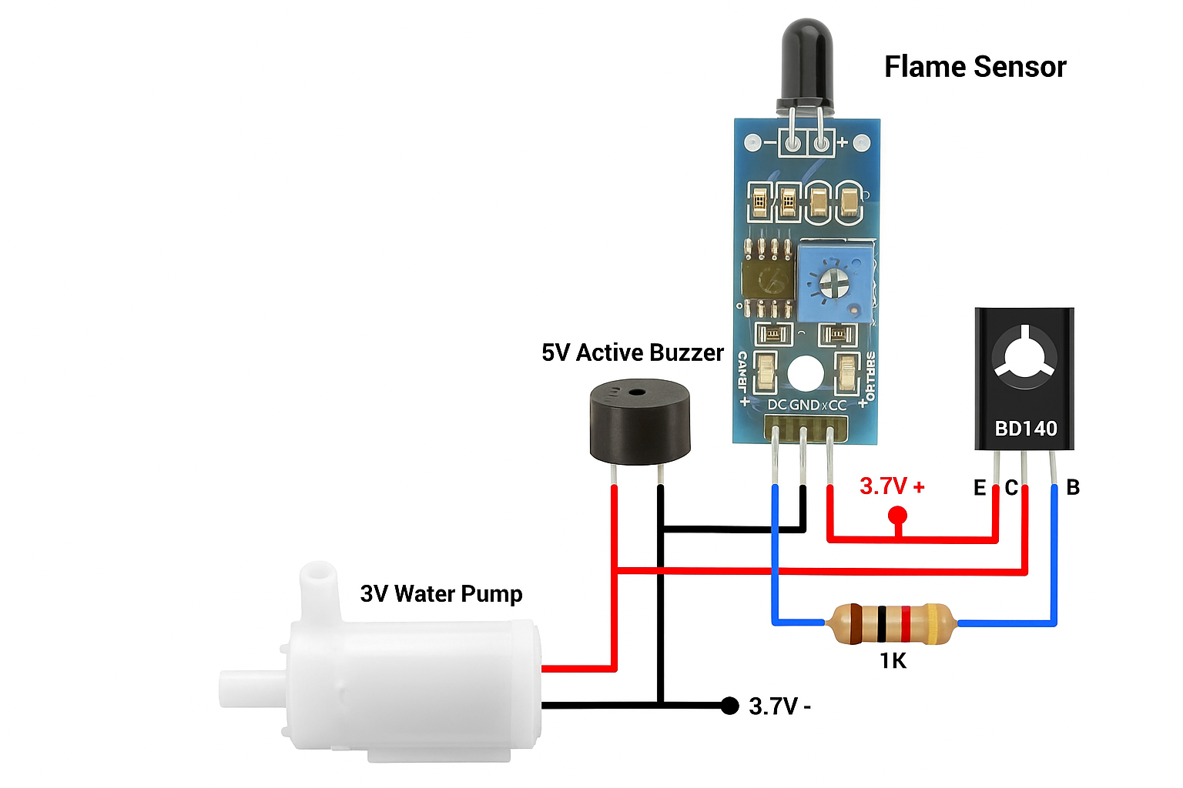

Fig 3.1 Circuit Diagram

EXPLANATION OF CIRCUIT DIAGRAM

The Agnirodhak circuit is a simple automatic fire detection and extinguishing system that operates using a flame sensor, BD140 transistor, 1kΩ resistor, buzzer, water pump, and a 3.7V battery. The flame sensor continuously monitors for fire by detecting infrared light. When no flame is present, its digital output remains high, keeping the transistor switched off so the water pump and buzzer stay inactive. When a flame is detected, the sensor’s output goes low, which activates the BD140 PNP transistor through the 1kΩ resistor. This allows current to flow from the emitter to the collector, powering both the water pump and buzzer. The pump then sprays water to extinguish the fire while the buzzer sounds an alarm to alert people nearby. Once the fire is put out, the sensor output returns to high, switching off the transistor and deactivating both devices. This compact, battery-powered circuit provides an efficient, low-cost, and automatic solution for fire detection and control without needing a microcontroller.

CHAPTER 4 HARDWARE DESCRIPTION
4.1 HARDWARE COMPONENTS
These are the following components we used to design our Project “AGNIRODHAK: AN AUTOMATED FIRE DETECTION & EXISTINGUISHING SYSTEM”.
- IR SENSOR MODULE
- BD140 PNP TRANSISTOR,
- 5V ACTIVE BUZZER
- 1K RESISTOR
- 3V WATER PUMP
- SWITCH
- 3.7BATTERY & BATTERY HOLDER
- TP4056 CHARGING MODULE.

IR SENSOR MODULE
The IR Sensor Module is used to detect the presence of fire or heat radiation in its
surrounding environment. It works based on the principle of infrared light
reflection. The sensor module contains an IR transmitter (which emits infrared
light) and an IR receiver (which detects the reflected light from nearby surfaces).
When a flame or strong heat source is present, the IR light emitted is absorbed and
reflected differently, causing a voltage change at the sensor output. This change is
processed by the connected circuit to trigger further actions.

The IR sensor module operates typically at 3.3V–5V DC and provides both analog
and digital outputs. In this project, the digital output pin is connected to the base
terminal of the BD140 transistor through a 1K resistor. When fire is detected,
the sensor sends a low signal, activating the transistor to turn ON the buzzer and
water pump automatically. The IR sensor is compact, power-efficient, and ideal
for low-cost fire detection applications.

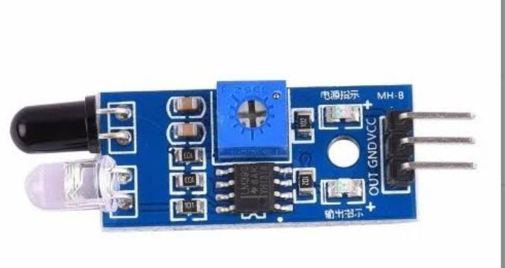

Fig 4.1 IR SENSOR MODULE

4.3 BD140 PNP TRANSISTOR
The BD140 transistor is a PNP power transistor used as a switching device in this project. It controls the operation of both the buzzer and the water pump based on the signal received from the IR sensor module. When the sensor detects a flame, its output becomes low, allowing current to flow from the emitter to the collector of the
transistor, thus powering the connected output devices. The BD140 transistor has a maximum collector current of 1.5A and a maximum voltage rating of 80V, making it suitable for controlling small DC motors and pumps. The transistor acts as an amplifier and switch, ensuring that the low current from the sensor is sufficient to drive higher current loads like the 3V pump and the 5V buzzer. This transistor is reliable, thermally stable, and commonly used in motor driver circuits and automation systems.

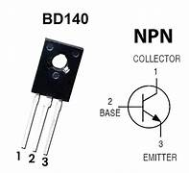

Fig 4.2 BD140 PNP TRANSISITOR

4.4. 5V BUZZER

The 5V Active Buzzer is an audio signaling device used to provide an alert when a

fire is detected. Unlike passive buzzers, an active buzzer contains an internal

oscillator, allowing it to produce sound directly when a DC voltage is applied. It

operates within a voltage range of 3V to 5V and produces a sound pressure level

of around 85–100 dB, which is easily noticeable in noisy environments.

In this circuit, the buzzer is connected in parallel with the water pump and is

powered through the BD140 transistor. When the transistor is switched ON by the

IR sensor, the buzzer emits a loud tone, warning nearby users of the detected fire.

The buzzer serves as an immediate audio alert mechanism, ensuring timely human

response before or during automatic fire extinguishing.


Fig 4.3 Buzzer

4.5 1KΩ RESISTOR
The 1KΩ resistor is used as a current-limiting resistor between the IR sensor’s output and the BD140 transistor’s base. Its main function is to protect the transistor from excessive base current that could otherwise damage the transistor junction. It ensures that only the required small current flows into the transistor base to switch it ON.
The resistor also stabilizes the signal by filtering noise or voltage fluctuations coming from the sensor output. This allows the circuit to respond accurately only when actual flame detection occurs. Using this 1KΩ resistor improves circuit reliability and ensures the long life of electronic components.



Fig 4.4 1KΩ RESISTOR

4.6 3V WATER PUMP
The 3V Mini Water Pump acts as the fire extinguishing component of the project. It is a small DC motor pump capable of drawing water from a reservoir and spraying it onto the fire source when activated. It operates efficiently on 3V–5V DC and consumes low current (around 300-500mA). In the circuit, the pump is powered through the BD140 transistor, which acts as a switch. When the IR sensor detects a flame, the transistor allows current to flow to the pump, automatically activating it. The water pump then sprays water until the flame is extinguished, after which the sensor stops triggering the transistor, turning off the pump. This ensures automatic fire control without manual intervention.

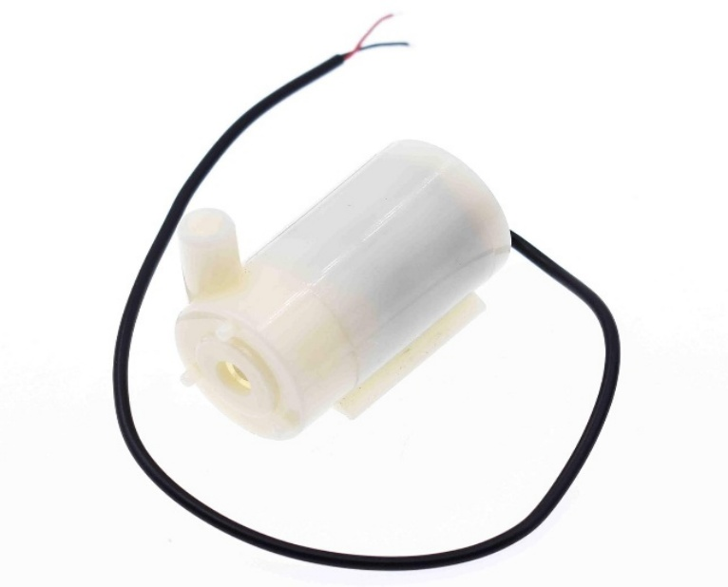

Fig 4.5 3V WATER PUMP

4.7 SWITCH

The switch serves as the main control unit to turn the entire circuit ON or OFF. It is connected between the battery and the circuit input, allowing safe and easy operation. The switch ensures that the system remains off during maintenance or when not in use, preventing unnecessary battery drainage. It also provides manual control to restart the circuit if needed after an operation cycle.
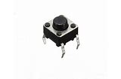

Fig 4.6 PUSH BUTTON (SWITCH)

4.8 3.7V Li-ion BATTERY
A 3.7V Lithium-ion battery serves as the main power source for the Agnirodhak system. It provides stable voltage and sufficient current to operate the flame sensor, transistor, water pump, and buzzer simultaneously. The battery holder ensures secure mounting and easy replacement of the battery when needed.
The Li-ion battery’s high energy density and rechargeability make it a suitable choice for portable applications. It powers the circuit efficiently for extended periods, ensuring continuous monitoring and rapid response during a fire event.

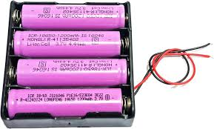

Fig 4.6 3.7V Li-ion BATTERY

4.9 TP4056 CHARGING MODULE
The TP4056 module is a Li-ion battery charging controller used to recharge the 3.7V battery safely through a USB or 5V DC source. It employs constant current–constant voltage (CC–CV) charging, protecting the battery from overcharging, over-discharging, and overheating.
The module features onboard LEDs to indicate charging and full-charge status. It also allows simultaneous charging and operation of the system, ensuring uninterrupted performance. Compact and cost-effective, the TP4056 enhances the portability and reusability of the Agnirodhak system.
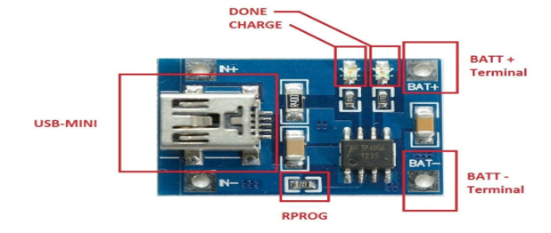

Fig 4.7 TP4056 CHARGING MODULE

CHAPTER 5 CONCLUSION AND FUTURE SCOPE
  - CONCLUSION
The Agnirodhak: An Automated Fire Extinguisher system represents a
reliable, efficient, and low-cost fire safety solution designed to minimize human
intervention and response time during fire incidents. By integrating a flame
sensor, transistor-based control circuit, DC water pump, and buzzer, the
system provides both automatic extinguishing and instant alerting capabilities.
The use of a BD140 PNP transistor amplifies the weak output signal from the IR
sensor, enabling it to drive higher current devices like the water pump and buzzer
effectively.
Powered by a 3.7V rechargeable Li-ion battery and managed through a TP4056
charging module, Agnirodhak ensures continuous and safe operation, even in
portable or remote environments. The design emphasizes simplicity,
affordability, and reliability, making it highly suitable for homes, laboratories,
workshops, and small industrial setups where large-scale fire suppression systems
are impractical or expensive.
By combining automation with accessibility, Agnirodhak demonstrates how
basic electronic components can be harnessed to develop intelligent safety
systems that protect lives and property. Ultimately, this project showcases a step
toward smart, self-acting fire prevention technology, contributing to a safer and
more responsive environment in both domestic and industrial contexts.

FUTURE SCOPE

The future scope of the Agnirodhak: An Automated Fire Extinguisher project extends toward the development of more intelligent, connected, and autonomous fire safety systems capable of operating in a wide range of environments. One promising direction is the integration of IoT connectivity using Wi-Fi, GSM, or LoRa modules to enable remote monitoring, real-time alerts, and data logging on cloud platforms, allowing users and authorities to receive instant notifications and analyze fire patterns for preventive measures.
Incorporating artificial intelligence (AI) and machine learning (ML) could further enhance the system’s efficiency by enabling smart fire detection and predictive risk analysis, distinguishing between real fire events and false alarms through pattern recognition. The addition of advanced sensors—such as smoke, temperature, and gas detectors—would improve detection accuracy and extend protection coverage to more complex industrial and residential environments.
Future versions could also employ robotic or drone-based extinguishing units to reach inaccessible areas or large-scale fire zones automatically. The implementation of solar-powered systems and energy-efficient components could make Agnirodhak more sustainable and suitable for continuous operation in remote or off-grid locations.
Moreover, integrating the system with centralized smart building frameworks or industrial automation networks would allow for synchronized responses—such as automatic shutdown of electrical circuits or ventilation control during a fire. Through these advancements, Agnirodhak has the potential to evolve into a comprehensive, AI-driven fire safety ecosystem, contributing significantly to the global movement toward smart, safe, and sustainable environments.

